**SAMER FARES**

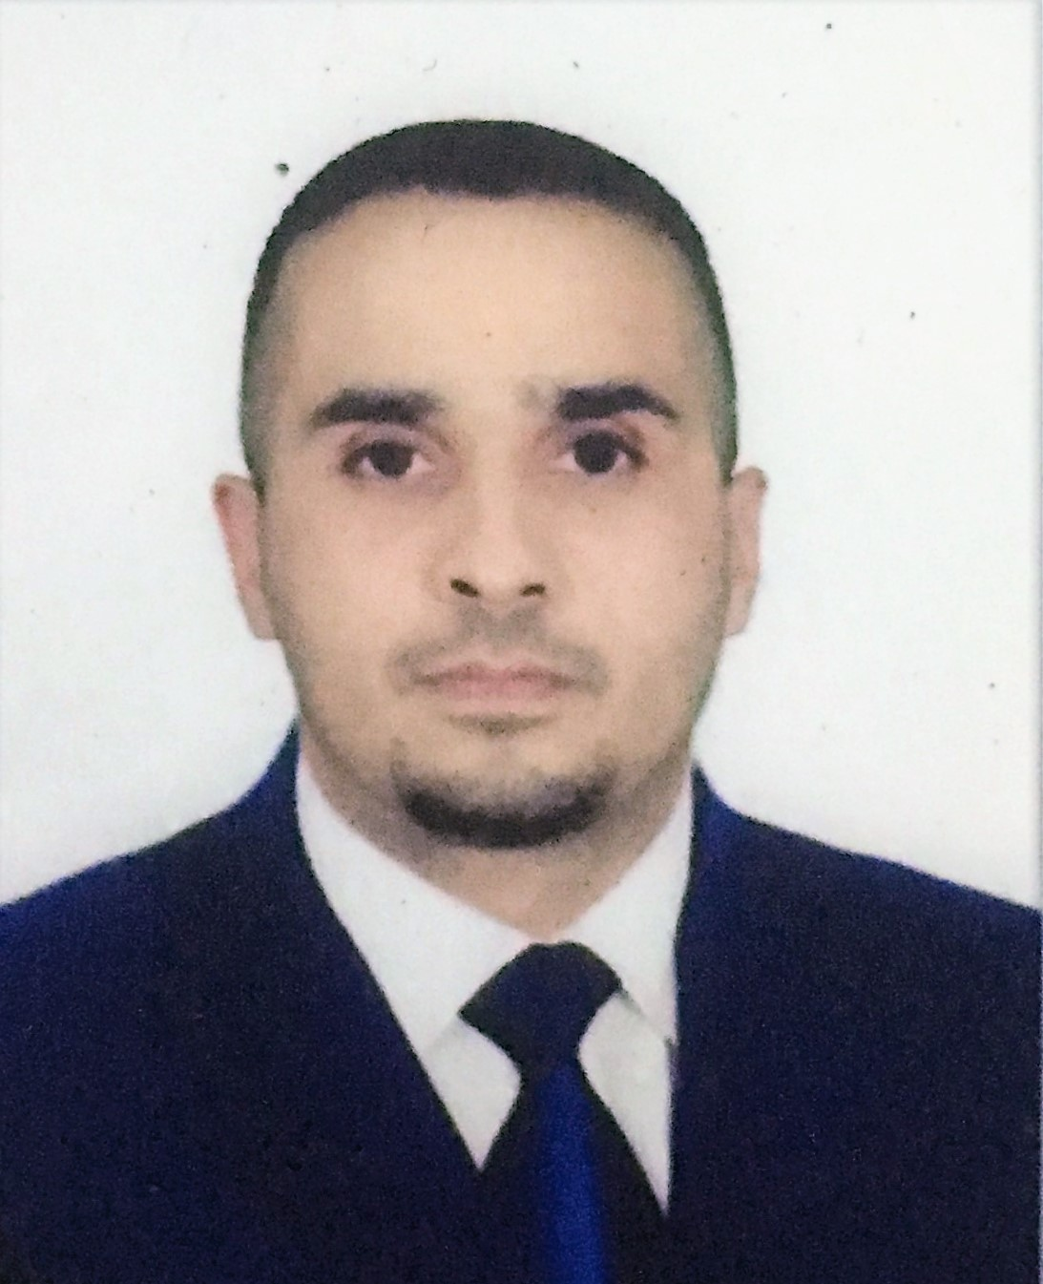

**009647815023347**

[**samer19892005@gmail.com**](mailto:samer19892005@gmail.com)

# **Skills**

* **Great command in using GAAP (Generally accepted accounting principles).**
* **Great command in using uniform accounting system.**
* **Expert in sage ERP/ odoo ERP / AlAmeen.**
* **Excellent Command in using MS Group.**
* **Great Knowledge of all accounting transactions.**
* **Good communication skills in both English and Arabic.**
* **Great knowledge in ICBS.**

# **EMPLOYMENT HISTORY**

**08/2014 - 10/2015 Accountant at Pepsi co.**

* **Provides financial information to management by researching and analyzing accounting data; preparing reports.**
* **Documents financial transactions by entering account information**
* **Recommends financial actions by analyzing accounting options.**
* **Summarizes current financial status by collecting information; preparing balance sheet, profit and loss statement, and other reports.**
* **Monitoring & supervision of the data entry team and ensuring proper record keeping.**

**11/2015 - 01/2017**

**Financial Auditor at Al-Handal International Group**

* **Collating, checking and analyzing spreadsheet data.**
* **Examining company accounts and financial control systems.**
* **Gauging levels of financial risk within organizations.**
* **Checking that financial reports and records are accurate and reliable.**
* **Ensuring that assets are safeguarded.**
* **Preparing reports, commentaries and financial statements.**
* **Liaising with managerial staff and presenting findings and recommendations.**
* **Ensuring procedures, policies, legislation and regulations are correctly followed and complied with.**
* **Undertaking reviews of wages.**
* **Responsibility to audit the Accounting five branches from al-Handal group ( Fly Emirates in Baghdad and Basrah, Paris Gallery in Baghdad, Ishtar for security services, Madinaty project in Karkuk, Today Fm ).**

**01/2017 – Present**

**Senior Accountant, at Ruban AlSafinah Group**

* **Analyze financial data to identify our company’s financial status**
* **Five months experience in Finance Department as a Financial Specialist at AlEqtisad Bank.**
* **Prepare budget reports.**
* **Develop financial models, taking legal limitations into consideration.**
* **Participate in regular audits and recommend corrective financial action plans.**
* **Design and review fiscal policies.**
* **Identifying if and where processes are not working as they should and advising on changes to be made.**
* **Identify investment opportunities.**
* **Advise our senior management team on financial planning.**
* **Create forecast models based on current and past financial results.**

# **EDUCATION HISTORY**

**2014 Al-Turath University Accounting, Bachelor's Degree**

**• My study based on classes that consisted of accounting, business, finance, math, and statistics.**